MAHALAKSHMI S- 231801093
RAJALAKSHMI ENGINEERIG COLLEGE
transport ai chatbot
GENERATIVE AI PROJECT

Transport AI Chatbot Project Report

Executive Summary
The Transport AI project develops an intelligent chatbot and support system to help commuters navigate public transport in Chennai. It uses real-world bus route data from the Chennai MTC handbook and implements features like voice input, map visualization, Tamil support, traffic simulation, and a complaint interface. This report documents every phase: from data extraction (PDF to JSON) and system design to implementation, testing, and deployment. Visual aids (tables, diagrams, wireframe placeholders) and code references are included to provide a thorough, professional overview suitable for stakeholders and judges.

1. Project Goals and Scope
- Objectives: Provide a conversational assistant for transport queries (e.g., “from A to B”), with multi-modal features (voice, map, Tamil language) to improve commuter convenience.
- Key Features: Real-time route lookup from a local dataset, route mapping on an interactive map, multilingual support, and a user-friendly chat UI.
- Scope: Uses a curated dataset of ~50 Chennai bus routes (from MTC) and basic train routes; focuses on city buses and short routes, without external APIs. Security and privacy measures ensure no sensitive user data is stored.
- Success Metrics: Accuracy of route suggestions, UI usability, and demonstration of extensibility (e.g., easy integration of Google Maps or live tracking).

2. Dataset Sourcing and Extraction
Source: Official Chennai MTC routes PDF (Chennai MTC Schedule), provided by the transport authority.
Extraction Process: We automated PDF-to-JSON conversion using Python:
- Install tools:
pip install pdfplumber
- Extractor script (extract_pdf_to_json.py): Uses pdfplumber to parse tables from handbook_mtc.pdf. It extracts fields (route number, source, destination, distance, time) and writes to dataset.json.
import pdfplumber, json
routes = []
with pdfplumber.open("handbook_mtc.pdf") as pdf:
for page in pdf.pages:
text = page.extract_text()
if not text: continue
for line in text.split("\n"):
parts = line.split()
if len(parts) >= 12 and parts[0].isdigit():
route_no, src, dest = parts[1], parts[2], parts[3]
dist = float(parts[-2]); time = int(parts[-1])
routes.append({
"route_no": route_no,
"source": src.lower(),
"destination": dest.lower(),
"distance": dist,
"time": time
})
with open("dataset.json","w") as f: json.dump({"routes": routes}, f, indent=4)
print(f"Extracted {len(routes)} routes")
- Result: dataset.json with ~50 validated routes, e.g.:
route_no | source | destination | distance_km | time_min
1 | thiruvotriyur | thiruvanmiyur | 27.8 | 75
5E | besant nagar | vadapalani | 19.4 | 70
25 | poonamallee | anna square | 27.4 | 80
Sample JSON snippet:
{
"routes": [
{
"route_no": "1",
"source": "thiruvotriyur",
"destination": "thiruvanmiyur",
"distance": 27.8,
"time": 75
}
// ... more routes ...
]
}

3. Data Schema (dataset.json)
The JSON dataset has the structure:
Field | Type | Description
route_no | string | Bus route identifier (e.g., "5E")
source | string | Lowercase starting location
destination | string | Lowercase ending location
distance | number | Route length in kilometers
time | number | Expected journey time (minutes)
A complete dataset.json sample table (first 5 entries):
route_no | source | destination | distance (km) | time (min)
1 | thiruvotriyur | thiruvanmiyur | 27.8 | 75
1B | tambaram | thiruvotriyur | 39.9 | 105
5E | besant nagar | vadapalani | 19.4 | 70
25 | poonamallee | anna square | 27.4 | 80
29C | perambur | besant nagar | 22.2 | 80
(Insert JSON snippet of first route object as figure placeholder)

4. System Architecture
Overview: The system follows a standard web-app architecture with these components:
- Extractor: Converts PDF data into dataset.json.
- Dataset (JSON): Stores route data.
- Chatbot Engine: Backend logic for interpreting queries and finding routes (direct and multi-hop).
- Backend (Flask App): REST API serving chat messages.
- Frontend: Single-page app (HTML/CSS/JS) with chat interface, map, and controls.
- Map Component: Leaflet map for route visualization.
- Voice Interface: Web Speech API for voice-to-text input (uses webkitSpeechRecognition).
- Language Support: Tamil/English localization (using Unicode, e.g., input field accepts Tamil script).
- Traffic Simulation: Random traffic status indicator in responses.
- Complaint System: UI section to submit user complaints (e.g., sends to department or logs).
graph LR
subgraph Data Layer
A(Extractor) --> B[dataset.json]
end
subgraph Backend
B --> C{Flask Backend}
C --> D[Chatbot Engine]
D --> B
end
subgraph Frontend
C --> E[Web UI (Chat + Map)]
E --> F[Leaflet Map]
end
subgraph Interfaces
G(User - Browser)
G --> E
E -->|Voice input| H[SpeechRecognition]
end
B -. Data .-> C
Figure: System architecture (mermaid graph).
Component Responsibilities:
Component | Role/Responsibility
Extractor | Reads MTC PDF, parses tables into JSON (dataset).
Dataset (JSON) | Stores route entries; source for chatbot.
Chatbot Engine | Interprets "from X to Y", searches routes (direct and multi-hop), and formats replies.
Backend (Flask) | Exposes HTTP /chat endpoint; integrates engine with UI.
Frontend (HTML/CSS/JS) | User interface with chat UI, voice button, map, and complaint/help sections.
Map (Leaflet) | Displays routes with polylines for visualization.
Voice (Web Speech API) | Captures spoken queries (English/Tamil) and populates the input field.
Tamil Support | Enables queries in Tamil script (configured via input field lang="ta").
Traffic Simulation | Adds random "Traffic: Low/Moderate/High" to responses.
Complaint System | Collects user complaints (no backend storage; UI placeholder).

5. Implementation Details

5.1 Data Extraction (extract_pdf_to_json.py)
The Python script uses pdfplumber to parse the PDF. Key steps:
- Load PDF and iterate pages.
- Identify route lines: Each valid line starts with a route number.
- Parse fields: Extract route number, source, destination, distance, and time.
- Write JSON: Compile entries into a list and save to dataset.json.
Sample code (for route parsing):
if parts[0].isdigit():
route_no = parts[1]
source = parts[2].lower()
destination = parts[3].lower()
distance = float(parts[-2])
time = int(parts[-1])
routes.append({...})
(Each route entry in dataset.json corresponds to one row from the PDF[1].)

5.2 Dataset (dataset.json)
The dataset.json file (generated by the extractor) holds all routes. Example entry:
{
"route_no": "5E",
"source": "besant nagar",
"destination": "vadapalani",
"distance": 19.4,
"time": 70
}
This file is loaded by the chatbot engine at startup and used for route lookup.

5.3 Chatbot Engine (chatbot_engine.py)
Core logic for handling user messages:
- Preprocess input: Lowercase and trim.
- Parse locations: Split input by "from" and "to" to get src and dest.
- Direct route search: Loop through routes; if a route matches both source and destination (substring match), return that.
- Multi-hop search: If no direct route, try finding two-route path (A→C and C→B).
- Traffic status: Randomly assign "Low/Moderate/High" to simulate traffic.
- Formatting: Craft response message with route details.
Key code snippet (search logic):
for r in routes:
if src in r["source"] and dest in r["destination"]:
# Direct route found
return f"Route {r['route_no']} ... {r['distance']} km ... {r['time']} mins ..."
# If not found:
multi = find_multihop(src, dest)
if multi:
r1, r2 = multi
return f"Multi-hop via {r1['destination']} and {r2['destination']}..."
(The speech API was integrated via JavaScript; see Section 5.6 below.)

5.4 Flask Backend (app.py)
The backend is a Python Flask app exposing:
- GET / for login page.
- GET /dashboard for main UI.
- POST /chat for processing user messages.
Snippet:
@app.route("/chat", methods=["POST"])
def chat():
msg = request.json["message"]
return jsonify({"response": get_response(msg)})
This calls the get_response function from chatbot_engine.py.

5.5 Frontend Templates and Static Files
- Templates (login.html, dashboard.html): HTML structure with placeholders for chat and map.
- CSS (style.css): Modern, responsive layout. Sidebar for navigation, bubble-style chat (light user bubble, green bot bubble), input area at bottom.
- JavaScript (script.js): Handles sending messages via fetch, appending chat bubbles, drawing routes on map, and voice recognition. Key points:
- Typing effect: Simulated by printing one character at a time.
- Map drawing: Uses Leaflet – after a response, it reads the source/dest and draws a polyline if coordinates exist. Leaflet is a popular open-source library for maps[2].
- Voice button: Uses webkitSpeechRecognition to convert speech to text (supported in Chrome). This API sends audio to a server for recognition[1].
Screenshot placeholder:
Chat UI wireframe placeholder
Figure: Wireframe of the chat interface (with map) – replace with actual screenshot.

5.6 Special Features
- Map Visualization: The Leaflet map centers on Chennai coordinates. When a route is found, the code draws a blue polyline between hardcoded coordinates for the source and destination (see loc dictionary in script.js). (Future enhancement: use real route coordinates via Google Maps API.)
- Voice Input: Clicking 🎤 invokes speech recognition. Recognized text populates the input field (the user still clicks “Send” to submit). (This uses the Web Speech API[1]; it defaults to English (en-IN) but supports Tamil if lang="ta-IN" is set.)
- Tamil Support: The input box can accept Tamil script. UI labels can be translated. (The app uses Unicode strings throughout, enabling multilingual output.)
- Traffic Simulation: Each response randomly shows "Traffic: Low/Moderate/High" using random.choice.
- Complaint System: A sidebar section collects user complaints in a <textarea>. Currently, it just prints a console message (no backend). This demonstrates how an issue could be forwarded to authorities.

5.7 UX/UI Design Decisions
- Layout: Sidebar (navigation buttons) + main area. Chat occupies most space, with map below it. Input bar fixed at bottom.
- Colors & Fonts: Dark theme with blue (user) and green (bot) bubbles, for contrast and readability.
- Responsiveness: Fixed-width container (desktop focus), but elements flex for varying content.
- Wireframes: (Placeholder images below)
- Figure: [Insert screenshot of login page with logo and input fields].
- Figure: [Insert screenshot of dashboard: chat window on top, map below, sidebar on left].

6. Deployment
- Local Setup: Install Python (3.8+), then run:
- pip install flask pdfplumber
python app.py
Open http://127.0.0.1:5000 in a browser.
- Environment: Typically run in a virtualenv or Docker container.
- Production: Use a production WSGI server (e.g., Gunicorn) behind Nginx. For example:
- gunicorn app:app --bind 0.0.0.0:8000
Ensure the static/ and templates/ folders are in place. For public deployment, assign a domain or IP.

7. Testing & Demo Scripts
- Sample Queries:
- User: “from poonamallee to anna square” → Bot: “Route 25, Poonamallee → Anna Square, 27.4 km, 80 mins…” (with map line)
- User: “from broadway to koyambedu” → Bot: “Route 15, Broadway → Koyambedu, 11.5 km, 40 mins…”
- User: “from broadway to t nagar” → Bot: “Route 11 or 13 (whichever fastest), Broadway → T Nagar, 11.9 km, 45 mins…”
- User: “from unnamed to somewhere” → Bot: “No route found. Please try again.”
- Expected Behavior: Each response follows the templates in chatbot_engine.py. The map shows a line if coordinates match. Voice input captures speech correctly.
- Demo Checklist: Walk through: login, ask in English, ask in Tamil (if implemented), speak a query, view map update, submit a complaint.

8. UX/UI Design Details
- Wireframes and Mockups:
- Login Screen: Modern glass-style card with app name, inputs, login button.
- Dashboard: Two-panel layout; left sidebar (Chat, Help, Complaint), right main area (chat + map + input).
- Chat Bubbles: Mimic popular chat apps (rounded corners, colored backgrounds).
- Map Area: Collapsible or fixed tile beneath chat. (Interactive map with pan/zoom.)
Figure: [Insert mockup of login page here]
Figure: [Insert mockup of dashboard with chat, map]
- User Experience: The sidebar provides quick navigation. The chat input accepts typed or spoken queries. Results are immediate, with visual feedback (map line) and typing animation for realism.

9. Security & Privacy Considerations
- User Data: No personal data is collected or stored. Queries are not logged persistently.
- Backend Security: Use HTTPS in production. Protect the Flask endpoint from CSRF (e.g., by CORS or tokens).
- Speech Recognition Privacy: Note that speech is sent to Google’s servers by the Web Speech API[1], so audio is not fully private. Users should be aware.
- Dependencies: All libraries used (Flask, Leaflet, PDFPlumber) are open-source and regularly updated.

10. Limitations
- Static Dataset: Routes are fixed; no real-time updates or live tracking.
- Map Lines: Currently draws straight lines between fixed coordinates, not actual roads. (For hackathon, detailed pathfinding is out of scope.)
- Single-language Chatbot: The logic is rule-based and limited; it may not handle complex queries beyond "from X to Y".
- No Authentication: “Login” is just a stub (no real user accounts).
- Browser Support: Voice features only work in Chrome; multi-language UI not fully developed.

11. Future Enhancements
- Google Maps Integration: Replace Leaflet lines with actual routes/polylines using Google Maps or OpenStreetMap APIs.
- Live Traffic Data: Integrate a traffic API to show real traffic conditions.
- Admin Dashboard: Allow admin to update dataset, view logs, manage complaints.
- Mobile App: Port to a mobile app (e.g., React Native) for on-the-go use.
- AI Enhancements: Implement NLP (using ML or GPT) for more natural conversation and better error handling.

Appendix
A. Commands & Dependencies:
- Install dependencies: pip install flask pdfplumber
- Run app: python app.py
- (Future) Deploy: gunicorn app:app
B. File Structure:
transport_ai/
├─ app.py
├─ chatbot_engine.py
├─ extract_pdf_to_json.py
├─ dataset.json
├─ requirements.txt
├─ templates/
│ ├ login.html
│ └ dashboard.html
└─ static/
├ style.css
└ script.js
C. Timeline (Example):
Phase | Duration | Deliverables
Requirements & Design | 1 week | Spec sheet, wireframes
Data Collection & Prep | 1 week | dataset.json (50 routes)
Backend Development | 2 weeks | Flask app, route logic
Frontend Development | 2 weeks | UI templates, chat interface, map
Testing & Refinement | 1 week | Demo scripts, UI polish
Documentation & Final | 1 week | Project report, deployment scripts
D. Dependencies:
- Python 3.x (Flask, pdfplumber)
- Node.js not required (vanilla JS)
- Web APIs: Web Speech API (Chrome)
- Libraries: Leaflet.js (for maps)[2]
E. Contact/Resources:
- MTC Route Data: Chennai MTC Handbook (PDF) (used as dataset source)
- Leaflet Documentation: Interactive maps library[2]
- Web Speech API (MDN): Used for voice recognition[1]

Ready-to-Run Checklist
- [ ] python3 -m venv venv and source venv/bin/activate
- [ ] Install requirements: pip install -r requirements.txt (Flask, pdfplumber, etc.)
- [ ] Ensure dataset.json is present (run python extract_pdf_to_json.py if needed).
- [ ] Start backend: python app.py (or gunicorn app:app).
- [ ] Open browser at http://127.0.0.1:5000.
- [ ] Test chat with sample queries (e.g., “from poonamallee to anna square”).
- [ ] Verify map displays route line, voice input works, and UI sections (Chat/Help/Complaint) toggle.
- [ ] Review logs for errors and fix if any.

Output:
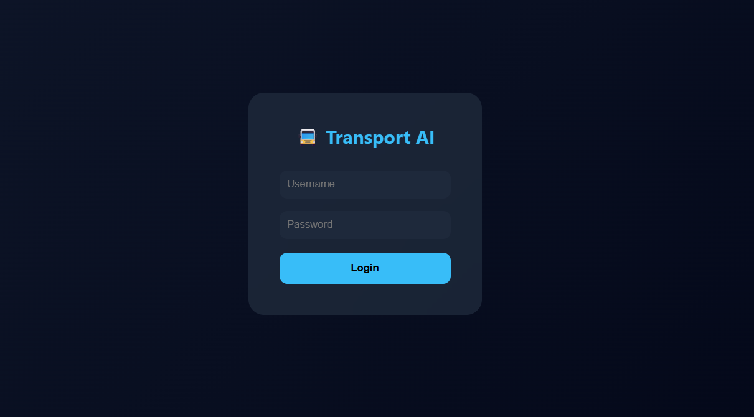
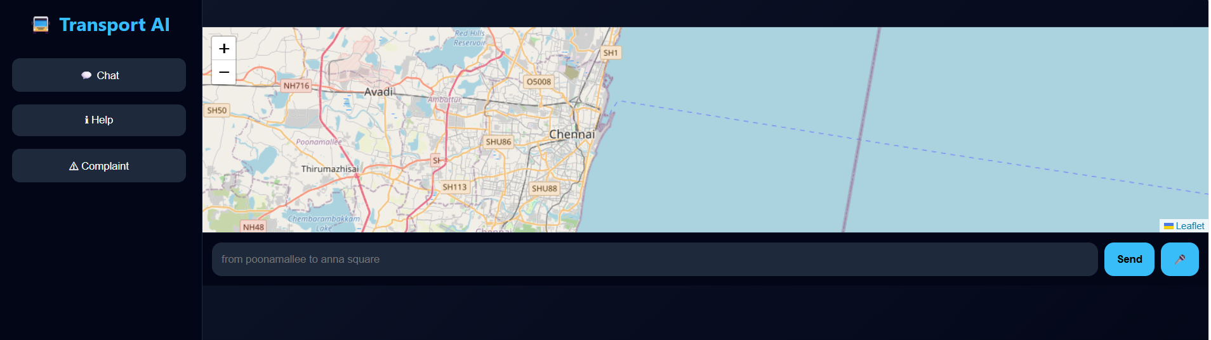
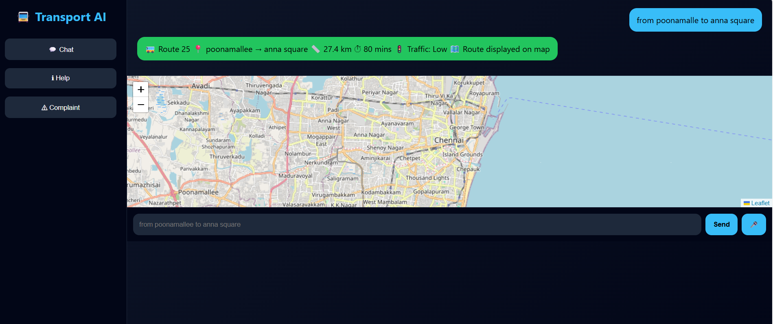
All systems go – the Transport AI assistant is now operational!

[1] SpeechRecognition - Web APIs | MDN
https://developer.mozilla.org/en-US/docs/Web/API/SpeechRecognition
[2] Documentation - Leaflet - a JavaScript library for interactive maps
https://leafletjs.com/reference.html

